**Computer Communication & Networks**

**SDN with default controller**

Name: Shravya Donthisaram

**1.** Mininet Topology Script

Mininet Topology.py

**2.**

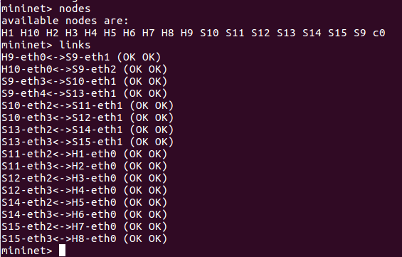

3. Packet Loss – 55% Dropped

This packet loss occurs one or more **packets** of data travelling across a **network** fail to reach their destination. Hosts marked as X in the output are unreachable by the hosts on the left

Example: Hosts H1 H2 H3 H4 and H9 are unreachable when pinged from host H6 as they have different network address ( 10.0.1.XX/24 for H1 H2 H3 H4 H9 and 10.0.2.11/24 for H6)

Packets to these unreachable hosts are dropped resulting in packet loss. In this scenario, network topology resulted in the packet loss.

4. **Scenario1:** Python script is “Mininet Topology Scenario 1.py”

Set link bandwidth between S9 ◊ S10 as bw=10Mbps

Set link bandwidth between S10 ◊ S12 as bw=15Mbps, delay = 10ms

**Scenario2:** Python script is “Mininet Topology Scenario 2.py”

Set link bandwidth between S9 ◊ S13 as bw=20Mbps  
Set link bandwidth between S13 ◊ S14 as bw=20Mbps, delay = 5ms

|  |  |  |  |  |  |
| --- | --- | --- | --- | --- | --- |
| **Host** | **IP address** | **Is this pingable from H9?** | **Is this pingable from H10?** | **Scenario:1 Measure bandwidth and delay using iperf on H9, H10** | **Scenario:2 Measure bandwidth and delay using iperf on H9, H10** |
|
| H1 | 10.0.1.10/24 | Yes | No | H9 - 0.095 ms, 11.4 Mbps H10 -unreachable | H9 - 0.347 ms, 12.3 Gbps H10 -unreachable |
| H2 | 10.0.1.11/24 | Yes | No | H9 - 0.08 ms, 11.5 Mbps H10 -unreachable | H9 - 0.085 ms, 14.6 Gbps H10 -unreachable |
| H3 | 10.0.1.12/24 | Yes | No | H9 - 20.25 ms, 11.6 Mbps H10 -unreachable | H9 - 0.066 ms, 11.5 Gbps H10 -unreachable |
| H4 | 10.0.1.13/24 | Yes | No | H9 - 20.31 ms, 11.1 Mbps H10 -unreachable | H9 - 0.092 ms, 12.6 Gbps H10 -unreachable |
| H5 | 10.0.2.10/24 | No | Yes | H9 - unreachable H10 -0.1 ms, 18.7 Gbps | H9 - unreachable H10 -10.257 ms, 22.1 Mpbs |
| H6 | 10.0.2.11/24 | No | Yes | H9 - unreachable H10 -0.085 ms, 17.4 Gbps | H9 - unreachable H10 -10.201 ms, 21.3 Mpbs |
| H7 | 10.0.2.12/24 | No | Yes | H9 - unreachable H10 -0.089 ms, 14.3 Gbps | H9 - unreachable H10 -0.083 ms, 21.7 Mpbs |
| H8 | 10.0.2.13/24 | No | Yes | H9 - unreachable H10 -0.088 ms, 15.1 Gbps | H9 - unreachable H10 -0.098 ms, 22.4 Mpbs |
| H9 | 10.0.1.1/24 | Yes | No | H9 - 0.053 ms, 18.1 Gbps H10 - unreachable | H9 - 0.046 ms, 15.6 Gbps H10 - unreachable |
| H10 | 10.0.2.1/24 | No | Yes | H9 - unreachable H10 - 0.045 ms, 15.2 Gbps | H9 - unreachable H10 - 0.042 ms, 13.4 Gbps |

**5.** Network is logically isolated into subnetworks using subnets (dividing IP address into Network and Host address). H9 forms a subnet with Hosts H1 H2 H3 and H4 as they have same network address(10.0.**1**.XX/24). Similarly, H10 forms a subnet with hosts H5 H6 H7 and H8 as they have same Network address (10.0.**2**.XX/24). Hosts in the subnet are unreachable to the hosts outside the subnetwork formed by subnetting i.e., nodes with IP addresses with a different network addresses. Hence, few nodes are in the subnet are reachable to the nodes with valid IP address (same network address) in the subnetwork and while few nodes are unable to reach other nodes (with different network address) outside the subnetwork.